PHASE 2 – Creating a Custom Table and Fields
Create the custom Employee Raise Issue table and configure the fields required to store employee issue information.

Objective
Create a custom table for Employee Raise Issue records and configure structured fields, choices, references, and auto-numbering.

Creating the Table
1. Navigate to System Definition → Tables.
2. Click New.
3. Set Label: Employee raises issue.
4. Allow the table name to auto-populate.
5. Under Controls, enable Auto number.
6. Save the table using the form context menu.

Creating Fields
- Open the table form and use Configure → Form Design to create the required fields.

Field Configuration
Number — Auto-Number
Requester — Reference to sys_user
Category — Choice: Network, Hardware, Software, Access
Subcategory — Choice: VPN, Laptop, Server, Forgot password
Short description — String
State — Choice: New, In progress, Resolved, Closed
Priority — Choice: Critical, High, Medium, Low
Assignment Group — Reference to sys_user_group
Employee raises issue table
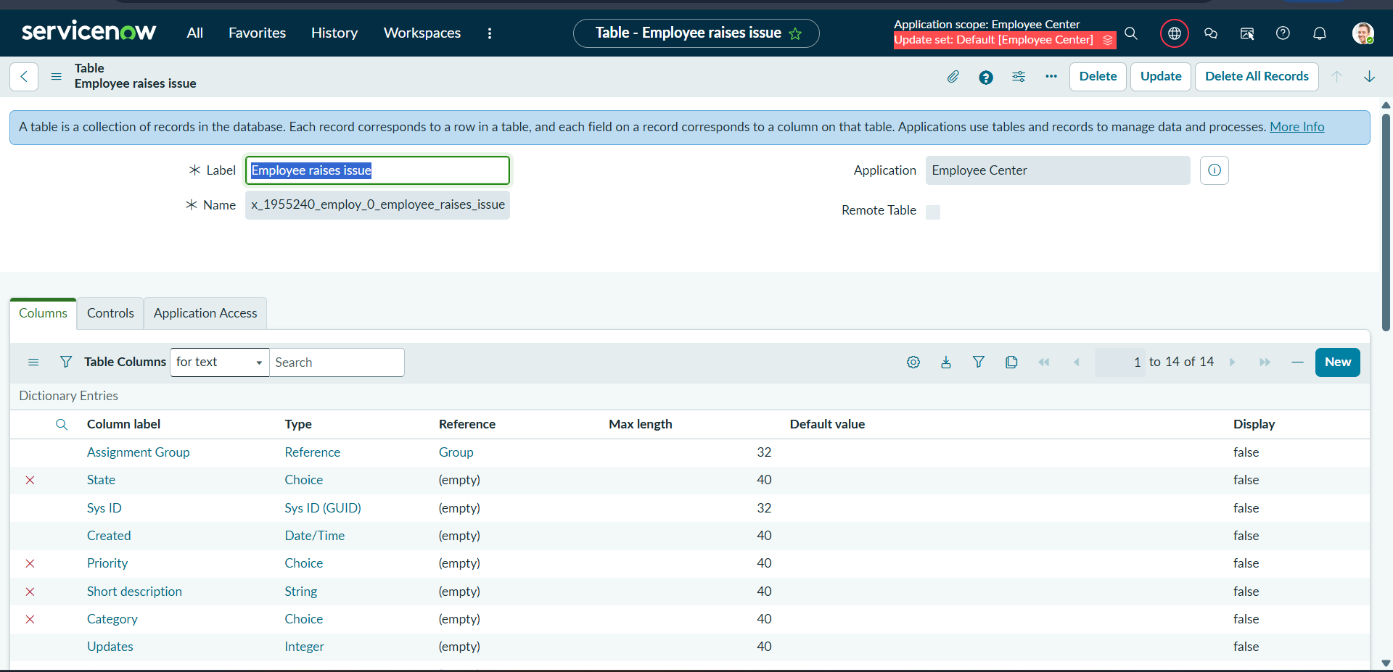

Table fields in Form Builder
